System Requirements Specification
Quick Grad Planner
Customer: Dr. John Callahan

South Pole Tigers

Payal Aggarwal
Heather Long
Christopher Stark
Emmanuel Tebong
Patrick Trinkle

October 9, 2005
Quick Grad Planner by South Pole Tigers
System Requirements Specification

Table of Contents

Page

1. Introduction 2
  - Purpose of This Document 2
  - References 2
  - Purpose of the Product 2
  - Product Scope 2

2. Functional Requirements 2
2.1 Introduction to Functional Requirements 2
2.2 Functional Requirement Use Cases 3

3. Non-Functional Requirements 19
3.1 Introduction to Non-Functional Requirements 19
3.2 How to read Non-Functional Requirements 19

4. User Interface 20

5. Deliverables 20
5.1 Deliverable Artifacts 20

6. Open Issues 21

Appendix A – Peer Review Sign-off 22

Appendix B – Agreement between Customer and Contractor 23

1. Introduction
  - Purpose of This Document
The purpose of this document is to present and explain the functional and non-functional requirements of the product to the customer, as well as the artifacts to be delivered and the dates of said delivery.

  - References

The Unified Modeling Language (UML): A Standard Graphical Notation presentation, by Eddie Roache, was used to gather and document the functional requirements. UML Distilled, by Martin Fowler, was referenced in the creation of the UML diagrams.
  - Purpose of the Product
The Quick Grad Planner was requested by the customer to meet student advising needs, namely allowing for accurate and error-free college major course scheduling. The customer will use the Quick Grad Planner with students enabling both the student and the customer a complete picture of the necessary requirements to graduate. This scheduler will assist in understanding the larger picture of the college career, in the sense of giving the student a method to see how their classes will flow and mix during their tenure, while giving them knowledge of the necessary prerequisites for each.

  - Product Scope

The Quick Grad Planner will adhere to Figure 1.1 as a general guideline to what the product will do, how users, or actors, will interact with the system at the highest level, and how the system will interact with external devices. In general, students themselves, alone or in conjunction with academic advisors, will use the system to create graduation plans, modify them, and view them for the purpose of cleanly reviewing the work they have done already or in a previous session. Also, they will be able to print the plan, for their own hard copy records.

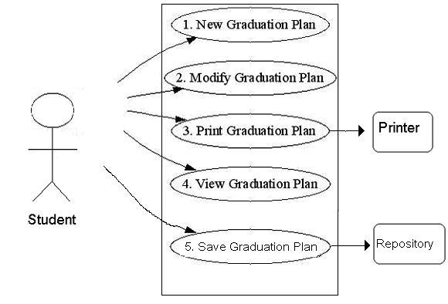
Figure 1.1 Product Scope Diagram

2. Functional Requirements

2.1 Explanation of Functional Requirements

Functional requirements are those that are actual services or tasks that the system will perform. These are represented by a use case, which are general, step-by-step walkthroughs of how the system can be used. Each use case will be accompanied by a use case diagram, further detailing through the use of visualization and the UML standard, the flow and feel of the system to be implemented. Also, each use case will have an associated priority, numbered 1-5, where 5 is the most critically important function of the product and 1 is the least. As a general rule, those number with a 5 priority will be the core functionality of the product.

2.2 Functional Requirement Use Cases

Number | 1
Name | Manage Graduation Plan
Summary | User will modify, create new, view, or print Graduation Plan data. System returns to this selection option upon completion.
Priority | 5
Preconditions | User is in the system
Postconditions | User may have changed, printed, or saved their Graduation Plan Data
Primary Actor(s) | Student
Secondary Actors | None
Trigger | User requests to modify, create new, view, or print their Graduation Plan
Main Scenario | Step | Action
 | 1 | System requests action to perform
 | 2a | User requests to modify Graduation Plan Data  Use Case 1a - Modify Graduation Plan Data
 | 2b | User requests to create a new Graduation Plan  Use Case 1b - New Graduation Plan
 | 2c | User requests to view Graduation Plan Data  Use Case 1c - View Graduation Plan Data
 | 2d | User Requests to Print Graduation Plan Data  Use Case 1d - Print Graduation Plan Data
 | 2e | User requests to Save Graduation Plan Data  Use Case 1e - Save Graduation Plan Data
Extensions | Step | Branching Action
 | 2f | User selects an invalid option  System requests for user selection again
Open Issues | None

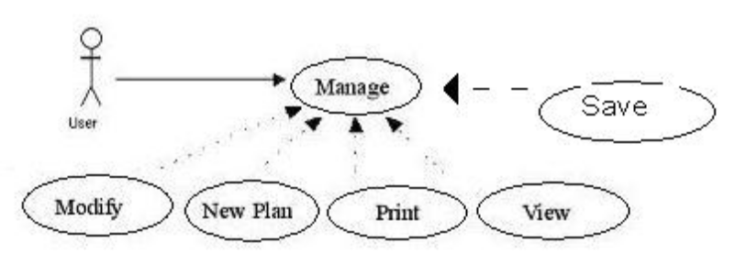
Figure 2.1 Manage Graduation Plan

Number | 1a
Name | Modify Graduation Plan
Summary | User requests to modify their graduation plan’s data. Options are to add a new semester or modify an existing semester.
Priority | 5
Preconditions | User is in the system, and has navigated to this dialogue. A Graduation Plan must exist (must have been created using Use Case 1b – New Graduation Plan) prior to attempting this course of action.
Postconditions | User may have modified a one or more course’s data
Primary Actor(s) | Student
Secondary Actors | None
Trigger | User requests to modify semester’s data
Main Scenario | Step | Action
 | 1 | System displays plan modification options
 | 2a | User requests to add a new semester  Use Case 1a1 – Add New Semester
 | 2b | User requests to modify an existing semester  Use Case 1a2 – Modify Semester Data
Extensions | Step | Branching Action
 | 2c | User selects an invalid option  System requests for user selection again
Open Issues | None

Number | 1a1
Name | Add New Semester
Summary | User requests to add a new semester to their graduation plan. New semester’s data is displayed.
Priority | 5
Preconditions | User is in the system, and has navigated to this dialogue. A Graduation Plan must exist (must have been created using Use Case 1b) prior to attempting this course of action.
Postconditions | User has added a new semester to their plan
Primary Actor(s) | Student
Secondary Actors | None
Trigger | User requests to modify semester’s data
Main Scenario | Step | Action
 | 1 | System requests the semester designator (Fall, Spring, etc…)
 | 2 | User specifies the course designator
 | 3 | System requests the year of this semester
 | 4 | User specifies the year of this semester
 | 5 | System displays the new semester and asks for confirmation of correctness
Extensions | Step | Branching Action
 | 2a | User requests a bad semester designator  User is asked for a correct semester designator
 | 4a | User requests a bad semester year  User is asked for a correct semester year
 | 5a | User does not approve of the semester data entered:  System asks for all course data again
Open Issues | None

Number | 1a2
Name | Modify Semester Data
Summary | User requests to modify a semester’s data. New semester’s data is displayed.
Priority | 5
Preconditions | User is in the system, and has navigated to this dialogue. A Graduation Plan must exist (must have been created using Use Case 005) prior to attempting this course of action.
Postconditions | User may have modified a one or more course’s data
Primary Actor(s) | Student
Secondary Actors | None
Trigger | User requests to modify semester’s data
Main Scenario | Step | Action
 | 1 | System displays the semester modification options
 | 2a | User requests to add a course  Use Case 1a1a – Add a Course
 | 2b | User requests to remove a course  Use Case 1a1b – Remove a Course
 | 2c | User requests to modify a course  Use Case 1a1c – Modify a Course
Extensions | Step | Branching Action
 | 2a | User requests a bad selection  System asks for correct selection
Open Issues | None

Number | 1a1a
Name | Add a Course
Summary | User requests to add a course to their semester
Priority | 5
Preconditions | User is in the system, and has navigated to this dialogue. A semester and a plan must exist (Use Cases 1b – New Graduation Plan and 1a1 – Add New Semester)
Postconditions | User has added a course to their semester
Primary Actor(s) | Student
Secondary Actors | None
Trigger | User requests to add a new course to their semester
Main Scenario | Step | Action
 | 1 | System requests the course designator (CMSC, IS, etc…)
 | 2 | User specifies the course designator
 | 3 | System requests the course number
 | 4 | User specifies the course number
 | 5 | System displays the new course and asks for confirmation of correctness
Extensions | Step | Branching Action
 | 2a | User requests a bad course designator  User is asked for a correct semester designator
 | 4a | User requests a course number  User is asked for a correct semester year
 | 5a | User does not approve of the course data entered:  System asks for all course data again
Open Issues | None

Number | 1a1b
Name | Remove a Course
Summary | User requests to remove a course. Existing courses are displayed for removal selection.
Priority | 5
Preconditions | User is in the system, and has navigated to this dialogue. At least one semester and some courses must exist.
Postconditions | User has removed a course from their semester
Primary Actor(s) | Student
Secondary Actors | None
Trigger | User requests to modify specific course data
Main Scenario | Step | Action
 | 1 | System displays a list of courses for this semester
 | 2 | User selects which course to remove
 | 3 | System asks for confirmation of correctness
Extensions | Step | Branching Action
 | 2a | User specifies an invalid course:  System notifies of bad input and asks again
Open Issues | None

Number | 1a1c
Name | Modify a Course
Summary | User requests to modify course data. Existing course and data are displayed, with options to modify the data.
Priority | 5
Preconditions | User is in the system, and has navigated to this dialogue
Postconditions | User may have modified a course’s data
Primary Actor(s) | Student
Secondary Actors | None
Trigger | User requests to modify specific course data
Main Scenario | Step | Action
 | 1 | User selects which data to modify
 | 2 | User modifies selected data
 | 3 | System displays edited course data and asks for User approval
 | 4 | System displays approved course modifications
Extensions | Step | Branching Action
 | 2a | User specifies any invalid course data:  System notifies of bad input and asks for that data again
 | 3a | User does not approve of the course data entered:  System asks for all course data again
Open Issues | None

Number | 1b
Name | New Graduation Plan
Summary | User requests to create a new graduation plan
Priority | 5
Preconditions | User is in the system
Postconditions | User has created a new graduation plan. Any previous graduation plan is lost.
Primary Actor(s) | Student
Secondary Actors | None
Trigger | User requests to input graduation plan data
Main Scenario | Step | Action
 | 1 | System requests the Student’s name
 | 2 | Student inputs their name
 | 3 | System requests the semester and year the graduation plan will begin
 | 4 | Student inputs the semester and year that the graduation plan will begin
 | 5 | System requests user to select a major and displays list of supported majors
 | 6 | Student selects the major for this graduation plan
 | 7 | System displays given information and asks for confirmation of correctness
Extensions | Step | Branching Action
 | 4a | User inputs a bad semester/year code  User is asked for a correct semester/year code
 | 6a | User inputs bad major selection  User is asked for a correct major selection
Open Issues | None

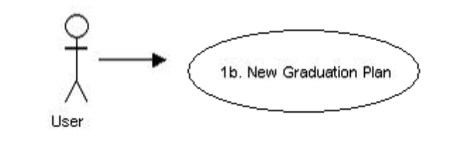
Figure 2.3 New Graduation Plan
Figure 2.3 New Graduation Plan

Number | 1c
Name | View Plan Data
Summary | User requests to view their plan’s data. Existing plan data is displayed.
Priority | 5
Preconditions | User is in the system
Postconditions | User has viewed their plan’s data
Primary Actor(s) | Student
Secondary Actors | None
Trigger | User requests to view their graduation plan data
Main Scenario | Step | Main Scenario
 | 1 | System requests a semester to view, or all remaining courses for graduation
 | 2a | User specifies a semester  Use Case 1c1 – View Semester Data
 | 2b | User specifies to view all remaining graduation courses  Use Case 1c2 – View Remaining Graduation Requirements
Extensions | Step | Extensions
 | 2a | User requests a bad semester  User is asked for a correct semester
Open Issues | None

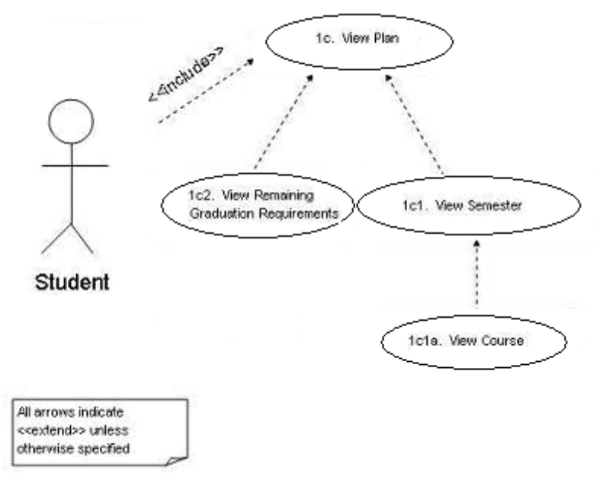
Figure 2.4 Manage Graduation Plan

Number | 1c1
Name | View Semester Data
Summary | User requests to view a semester’s data. Existing semester’s data is displayed.
Priority | 4
Preconditions | User is in the system, and has navigated to this dialogue
Postconditions | User has viewed some or all of the semester’s data
Primary Actor(s) | Student
Secondary Actors | None
Trigger | User requests to view a semester’s data
Main Scenario | Step | Action
 | 1 | System displays a summary of the semester
 | 2 | System asks user if they would like to view a specific course in more detail
 | 3 | User requests to view a specific course  Use Case 1c1a – View Course Data
Extensions | Step | Branching Action
 | 3a | User requests a bad course  User is asked for a correct course
Open Issues | None

Number | 1c1a
Name | View Course Data
Summary | User requests to view course data. Existing course data is displayed.
Priority | 5
Preconditions | User is in the system, and has navigated to this dialogue
Postconditions | User has viewed a course’s data course data
Primary Actor(s) | Student
Secondary Actors | None
Trigger | User requests to view course data
Main Scenario | Step | Action
 | 1 | System displays course data
Extensions | Step | Branching Action
 | 2c | User selects an invalid option  System requests for user selection again
Open Issues | None

Number | 1c2
Name | View Remaining Graduation Requirements
Summary | User requests to view the courses remaining for graduation. Remaining courses required for graduation in their specific major are displayed.
Priority | 5
Preconditions | User is in the system and at the opening dialogue
Postconditions | User has viewed the courses remaining for graduation
Primary Actor(s) | Student
Secondary Actors | None
Trigger | User requests to view remaining courses for graduation
Main Scenario | Step | Action
 | 1 | User requests to view remaining courses for graduation
 | 2 | System displays courses remaining for graduation
Extensions | Step | Branching Action
 | 3c | User selects an invalid option  System requests for user selection again
Open Issues | None

Number | 1d
Name | Print Graduation Plan
Summary | User requests to print their graduation plan data
Priority | 3
Preconditions | User is in the system and at the opening dialogue
Postconditions | User has printed some or all of the courses or semesters in their plan
Primary Actor(s) | Student
Secondary Actors | None
Trigger | User requests to print their graduation plan data
Main Scenario | Step | Action
 | 1 | System requests for user to print entire plan, or parts of a plan
 | 2a | User selects to print entire plan  Use Case 1d1 – Print Entire Plan
 | 2b | User selects to print parts of the plan  Use Case 1d2 – Print Parts of Plan
Extensions | Step | Branching Action
 | 2c | User selects an invalid option  System requests for user selection again
Open Issues | None

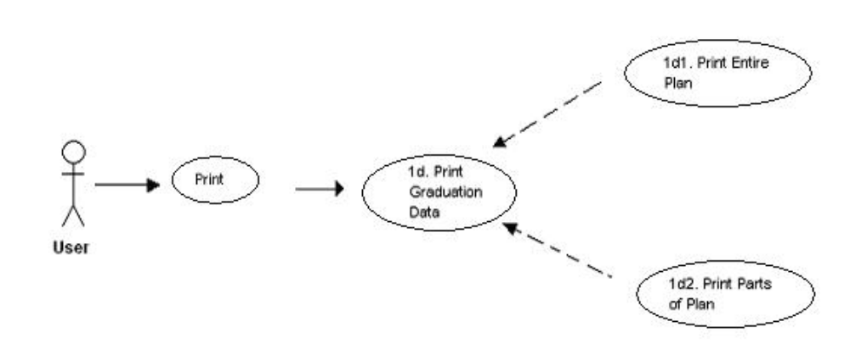
All arrows indicate
<<extend>> unless otherwise specified
Figure 2.5 Manage Graduation Plan

Number | 1d1
Name | Print Entire Plan
Summary | User requests to print their entire graduation plan
Priority | 3
Preconditions | User is in the system and has navigated to this dialogue
Postconditions | User has printed all of the semesters in their plan
Primary Actor(s) | Student
Secondary Actors | None
Trigger | User requests to print their entire graduation plan data
Main Scenario | Step | Action
 | 1 | System prints entire plan
Extensions | Step | Branching Action
 | 2c | User selects an invalid option  System requests for user selection again
Open Issues | None

Number | 1d2
Name | Print Parts of Plan
Summary | User requests to print parts of their plan
Priority | 2
Preconditions | User is in the system and has navigated to this dialogue
Postconditions | User has printed some of the semesters in their plan
Primary Actor(s) | Student
Secondary Actors | None
Trigger | User requests to print some of their graduation plan data
Main Scenario | Step | Action
 | 1 | System displays a list of semesters and requests semesters to print
 | 2 | User specifies range of semesters to print
 | 3 | System prints specified semesters
Extensions | Step | Branching Action
 | 2a | User specifies an invalid range of semesters to print  System requests for a new range to print
Open Issues | None

Number | 1e
Name | Save Graduation Plan
Summary | User requests to save their graduation plan data
Priority | 3
Preconditions | User is in the system and at the opening dialogue
Postconditions | User has save their Graduation Plan
Primary Actor(s) | Student
Secondary Actors | None
Trigger | User requests to save their graduation plan data
Main Scenario | Step | Action
 | 1 | System saves users graduation plan
Extensions | Step | Branching Action
Open Issues | None

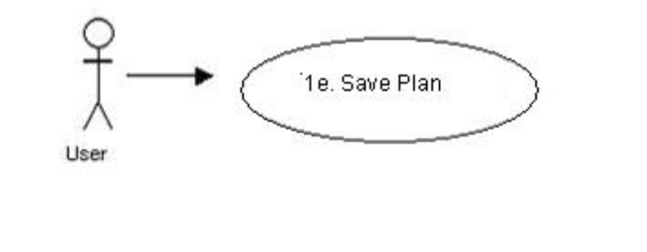
Figure 2.6 Save Graduation Plan

3. Non-Functional Requirements

3.1 Introduction to Non-Functional Requirements

The following is a list of the non-functional requirements of the system. These requirements are not parts of the product that would perform a working service, but are constraints or specifications nonetheless.

3.2 How to Read the Non-Functional Requirements

Non-functional requirements are constraints on the services or functions offered by the system. This section of the document identifies the additional requirements of the system aside from functional requirements. Each non-functional requirement is assigned a priority. This priority number is used to measure the importance of each requirement of the system. During the development of a product, these priority numbers assist in determining which functionality will be implemented first. A priority number of 5 indicates the most important requirement, with a priority of 1 then being the least important requirement.

Number | Priority | Non-Functional Requirement
1 | 4 | The system will handle user selection using menus.
2 | 5 | The system will check to see if an added course’s prerequisites have been fulfilled.
3 | 2 | The system will interface with a printer external to the system.
4 | 5 | The system will operate on a single-user Windows-based personal PC, using an ssh client to interface with a linux machine (which must have g++ on it).
5 | 5 | The system will handle only the following majors: CMSC, IS, CMSC/IS double major, IS major with a CMSC minor.
6 | 3 | The system will be a stand-alone desktop application.
7 | 1 | The student’s data will be transferable to another computer, but will replace any other QGP data running on the other computer.
8 | 5 | The user interface will be text-based interface.
9 | 3 | The system will be implemented in C++.
10 | 5 | The system will show what required courses still need to be taken.
11 | 4 | The user’s data will be stored in an Oracle database.
12 | 5 | The system will show courses already taken, organized by semester.
13 | 3 | The system will be developed using an incremental delivery development process, while retaining the general structure of a Waterfall process.
14 | 1 | The system shall allow addition of specific comments to specific courses
15 | 5

4. User Interface

See User Interface Design Document for Quick Grad Planner.

5. Deliverables

5.1 Deliverable Artifacts

Deliverables are the artifacts to be given to the customer upon completion of the product. Also specified is the format of the artifact, and a proposed date for each.

Deliverable | Format | Date
Systems Requirement Specification | Hard copy | 10th October
Incremental Delivery Reports | CD/Internet | Variable, throughout project lifecycle. (See Open Issue 2)
System Design Document | Hard copy | 1st November
UI Design Document | Hard copy | 1st November
Biweekly Status Reports | Hard copy | September 27th, October 11th, October 25th, November 8th, November 11th
User Manual | Hard copy | 8th December
Administrator Manual | Hard copy | 8th December
“Read Me First” Document | CD | 8th December
Installation Instructions | CD | 8th December
User Manual | CD | 8th December
Administrator Manual | CD | 8th December
System Requirements Specification | CD | 8th December
System Design Document | CD | 8th December
UI Design Document | CD | 8th December
Code Inspection Report | CD | 8th December
Test Report | CD | 8th December
Source Code | CD | 8th December
Quick Grad Planner | CD | 8th December

6. Open Issues

Open issues are areas that have not been resolved as of the delivery of this document, and are subject to change as the product is developed.

Issue Number | Description
1 | Due to customer request we are going to be using a text-based User Interface, however, we are still in the process of deciding if we will use a regular text-based UI or use special software to allow more complex and involved UI while remaining text-based. Though this is not a requirement, it could very much affect the rest of the program.
2 | Due to customer requested of a modified waterfall approach, namely waterfall with the added stipulation of incremental development, a method of how to deliver the required documentation and code for our project at the scheduled time using this incremental approach has not yet been determined.

Appendix A – Peer Review Sign-off

This is to denote and confirm that all members of the Quick Grad Planner team have seen and approved this requirements document, that it meets their standards of excellence and conveys the information that was agreed upon and will be done in the project. We, the undersigned, agree and confirm that the document above is our own work and approve of its contents with any additional comments to be noted upon signing.
NAME DATE
Payal Aggarwal
__________________________ __________________________

Heather Long
__________________________ __________________________

Christopher Stark
__________________________ __________________________

Emmanuel Tebong
__________________________ __________________________

Patrick Trinkle
__________________________ __________________________

Team Member Comments:
Appendix B – Agreement between Customer and Contractor
This is to denote and confirm that all members of the Quick Grad Planner team have met with our customer, Dr. Callahan, and both parties have approved the requirements document for the Quick Grad Planner product. It meets our standards of excellence and conveys the information that was agreed upon and will be done in the project. We, the undersigned, agree and confirm that the document above is our own work and approve of its contents, with any additional comments to be noted upon signing. Any changes that need to be made to this document, reflecting any changes made to specific requirements of the product, will be agreed upon by all parties before committing.
NAME DATE
Payal Aggarwal
__________________________ __________________________

Heather Long
__________________________ __________________________

Christopher Stark
__________________________ __________________________

Emmanuel Tebong
__________________________ __________________________

Patrick Trinkle
__________________________ __________________________

Dr. John Callahan
__________________________ __________________________
Customer Comments:

